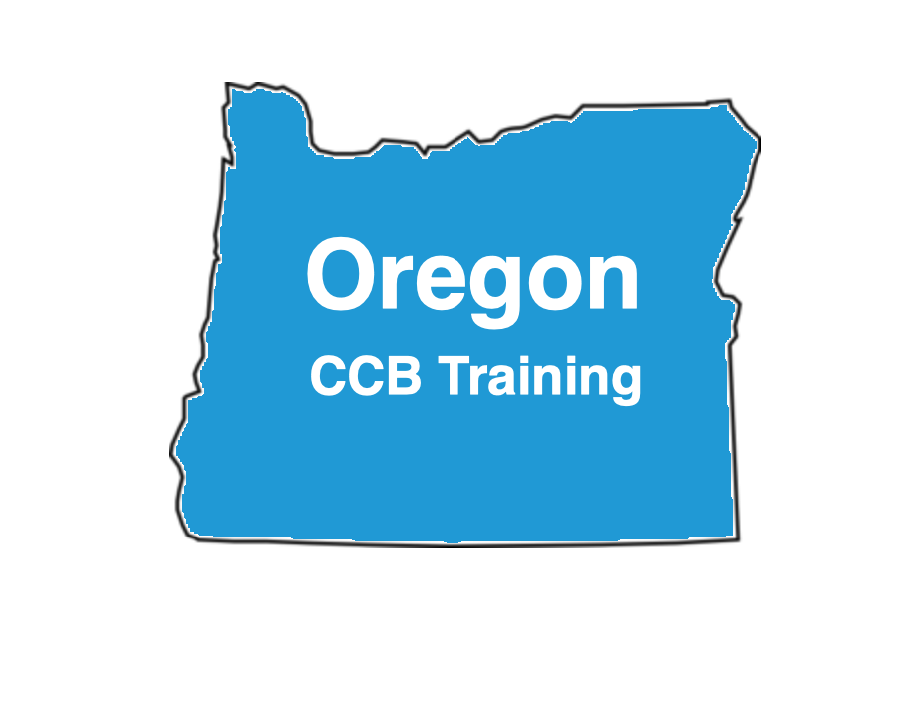

Phone: 503-888-1708
Email: oregonccbtraining@gmail.com

Next Steps:

The Oregon Construction Contractors Board (CCB) needs know that you have read the latest Oregon Contractor Reference Manual (enclosed) prior to becoming licensed. It is pretty easy reading and the information you will learn from it will help your business a great deal. By understanding the Oregon Contractor Reference Manual it will reduce or eliminate future problems down the road.

After you have read the Oregon Contractor Reference Manual for no less than 16 hours and approximately no less than 1 hour and 9 minutes per chapter, then you will need to login into www.oregonccbtraining.com, fill out the Course Completion Form and click submit (Allow up to 48 hours to then receive your confirmation email from PSI Exams). Note: You also have unlimited access to our Oregon CCB approved 400 online bonus practice questions at www.oregonccbtraining.com.

Then, you may call PSI Exams at 800-733-9267 or schedule your exam online at www.psiexams.com. Your student ID number is your driver’s license number or alternative ID number you provided to us on your course completion form.

Test Taking Tips:

Place each of the attached permanent tabs at the beginning of its corresponding section in your CCB manual. They are designed to help you flip from one chapter to another more efficiently during your open book CCB exam.

During the open book CCB exam simply reference keywords within each question to the index of the CCB manual, then flip to the page number(s) relating to the question. This should help you find the page number(s) where you may verify that your answer is correct.

Memorize and get familiar with the chapter titles, section headings, and the index prior to taking the open book exam.

Avoid spending too much time on the more difficult questions. Instead make your best guess, flag the question, and save it to work on at the very end if you have any time left over. The point we are trying to make is that you do not want to be on question 60 out of 80 with no time left.

Utilize the entire time (3 hours) allowed to verify your answers in the book (do not leave early).

